January 2024 Newsletter: Paven Pulse #17

Send date: Jan. 28, 2025

Items we’ll cover:
- Current month theme: New year, new you
  - Poll roundup: Survey results
  - ICYMI
    - New 401(k) and IRA maxes for 2025
    - Collegewise
    - Health Savings Brokerage Account (HSBA)
    - Save on Meta Smart Glasses with your VSP benefit
    - Find and give support for LA wildfire victims
- Intro next month’s theme: Love your finances, love yourself
  - What’s next:
    - Benefit spotlight: Self-care with Lyra
    - Retirement goal video demo
    - RSU vesting reminder

Audience: All Paven users (dormant, disengaged, active, engaged)

Subject line:
New ways to make progress on your goals
Need help improving your finances in 2025?
Resources for improving your finances/achieving your goals
Making progress on your goals in 2025
Your Meta benefit updates for 2025
Check in on your goals and benefits for 2025

Nameplate | Paven Pulse  Issue #17
Top headline | The countdown on your 2024 goals has begun  2025 is under way  One month down
Content  Illustration idea:  Let’s repurpose some of the cover art from the video:  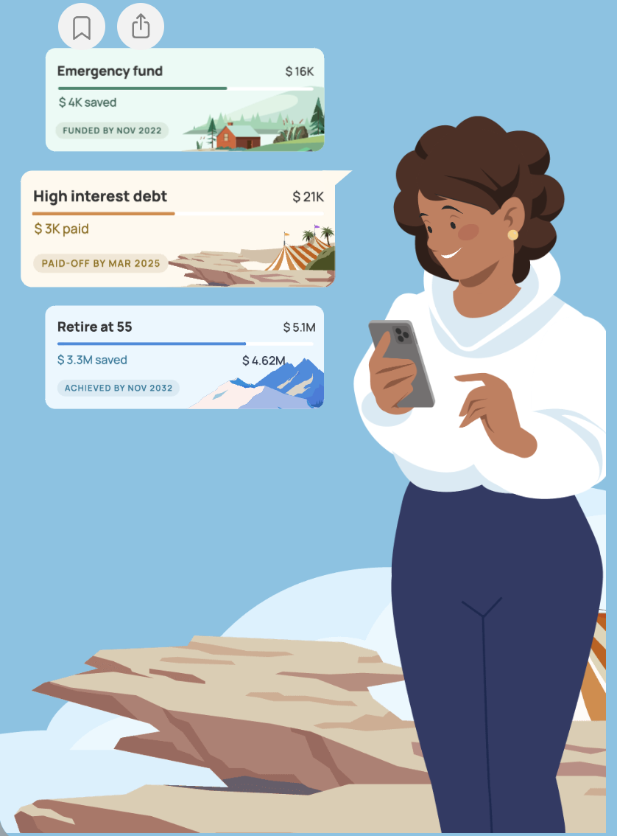 | January is coming to a close, but it’s not too late to lay out your financial goals for 2025.  Whether you’re paying down debt or buying a home, visualizing your roadmap to success can be tough. But with Paven, you can easily track and make meaningful progress towards your goals.  Want to learn how you can start tracking your goals in Paven? Watch our short tutorial video to see how it’s done.
CTA Button | VIDEO: How to set goals in Paven  <https://paven.io/content/video/6LepCKQ6zAQFLsTElijxVS>
Contact us banner | Need a hand or have an idea? Our inbox is always open. Just send a message to support@paven.app.
Poll recap header | POLL RESULTS  Did you take a penny or leave a penny?
Poll recap content  Illustration idea:  Resize this guy from our poll design:   | If you took the January Paven Poll, you did both! We gave a penny for your thoughts and you gave us several pennies in the wishing well for knowledge. Here’s a recap of results:  - XX % said …  - XX% said …  - 32% said they wanted to know more about retirement savings, while only 7% wanted to learn about paying down debt.  Check your answers against others or take the January Paven Poll for the first time to add your perspective. Every answer you give us is like a penny in our pocket – which we will spend on creating new content to meet your needs!  Join our research community  January’s poll also revealed that over half (54%) of your colleagues had other financial knowledge gaps to fill when selecting between wanting to learn about retirement or paying down debt. We want to know what those gaps are! Tell us directly by joining our Paven research community.
CTA Button | Join now  < https://forms.office.com/Pages/ResponsePage.aspx?id=Sx9DpAfCM0eVMDTAipsrjVAV8ActHlxDsCEdo8cXBjRUMk9HUEszTVZFQkg0NTY0MFAzNEE0RUVGRC4u >
Contact us banner | Need a hand or have an idea? Our inbox is always open. Just send a message to support@paven.app.
What’s new header |  | WHAT’S NEW  New year, new benefit updates
What’s new content  Illustration idea:  Something like this would be cute:   |  | The year began with a running start here at Paven! We shared lots of updates with you about your financial and wellness benefits, including:  - New 401(k) and IRA maxes for 2025: The IRS contribution limits and Meta’s 401(k) match have increased for this year.  - Unlock your child’s potential with Collegewise: Our first benefit spotlight of the year, Collegewise helps you navigate the college admissions maze.  - Your health savings brokerage account (HSBA): Learn how you can help fund your healthcare, retirement, and investments with an HSBA.  - Deals on Meta smart glasses: If you’re enrolled in a VSP vision plan, you can get a discount on high-tech eyewear.  Our hearts go out to everyone affected by the LA wildfires. If you need help or want to support the recovery efforts, please review this article for ideas and resources:  - Support for LA wildfire victims
CTA Button |  | Explore more on Paven <https://paven.io/home>
What’s next header |  | WHAT’S NEXT  Invest in love
What’s next content  Illustration idea:  Something along these lines for the “invest in love” theme:   |  | Investments come in many forms. Investing in the stock market is one thing, but you can also invest in yourself and your relationships. Are you investing in all the things you love?  During the month of February, we’re going to highlight all the ways you can invest in love. It’s our little valentine to you.  Look for “love letters” from Paven on the following topics over the next month:  - Invest in love—for your mental health  - Invest in love—for your retirement  - Invest in love—for your financial wellbeing  - Invest in love—for your family
Sign off |  | Congratulations on making it through the first month of the year! See you in February.  ~The Paven Team
Branch.io links

